# Evaluation

In this section, the results obtained from the game and saved in the database are extracted and evaluated. The aim is to determine whether the trolley dilemma would be successful or not in AV cars, while showing the different responses made by participants who choose different directions in reaction to the same traffic accident. From these results a general idea could be drawn based on the majority of the decisions taken by the participants for the same scenario.

The following will be presented:

1. The percentage of the participants who took the Utilitarian approach (chose to save the most lives);
2. The percentage of the participants who choose to uphold the law;
3. The most killed character/group;
4. The percentage of the participants who valued human lives over those of animals;
5. The percentage of the participants who chose whom to kill according to the age group of the character;
6. Average time taken to decide;

The above results will be divided according to demographic information such as gender, age or nationality as required. The results will determine the preferred approach in such situations and thus, the preferred reasoning autonomous cars should adopt when faced with the Trolley Dilemma.

## Evaluation of Participants

In total, 511 participants played the game, putting in 4083 responses. 64.19% of participants were males (328), putting in 2604 (63.77%) responses, while 33.86% were females (173), putting in 1428 (34.97%) responses. The rest (1.95%, 10 participants), identify themselves with other genders. 19 participants were under 18 years of age, 453 participants fall in the 18-34 age-group, 28 participants were between 35 and 54 years old, and 11 participants were over 55 years of age. 83.17% of participants were Maltese, contributing to 3498 responses, and the rest come from more than 17 other countries around the world, including the United States of America (2.15%), Australia (1.57%), and Canada (1.57%).

## Most Killed Characters

The most killed character was the dog. The dog was presented in 849 scenarios and killed in 53.95% of them. When presented against any other character in the game (Figure 1), including the car passengers, the dog is nearly always chosen to die. The only exception is groups of old women, where, in this scenario, dogs were killed 15.63% of the time and old women were killed in 37.5% of the responses. This clearly portrays the participants’ belief that preserving human life is much more important than protecting animals.

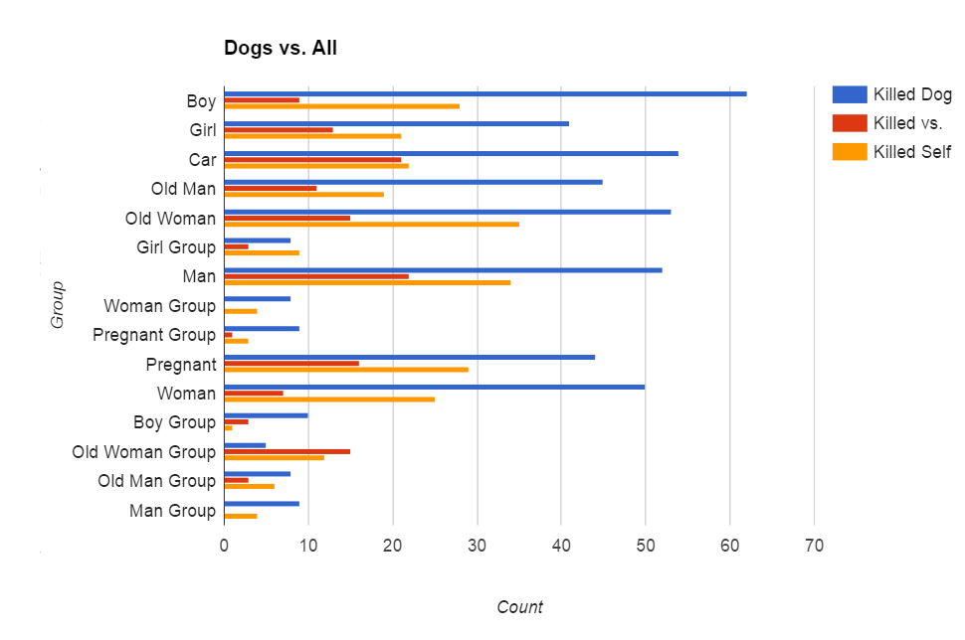

Figure 4 – Comparison of the choice to kill the dog/s against each of the other characters

Table 1 shows more valuable information on which characters participants decided to save. Children and adults were killed only 15.04% and 18.28% of the time respectively, whereas old people were killed 35.46% of the time. Gender also plays a small part in the choices made, as males were killed in 24.11% of the scenarios presented, compared to females at 21.12%. It is clearly noticeable that the boy group was given most importance as they were saved 91.49% of the time.

| Choice | Count | Kill Count | % |
| --- | --- | --- | --- |
| Boy | 788 | 121 | 15.36% |
| Boy Group | 141 | 12 | 8.51% |
| Car | 815 | 366 | 44.91% |
| Dog | 849 | 458 | 53.95% |
| Dog Group | 106 | 43 | 40.57% |
| Girl | 730 | 120 | 16.44% |
| Girl Group | 129 | 16 | 12.40% |
| Man | 785 | 194 | 24.71% |
| Man Group | 136 | 21 | 15.44% |
| Old Man | 769 | 281 | 36.54% |
| Old Man Group | 143 | 37 | 25.87% |
| Old Woman | 825 | 322 | 39.03% |
| Old Woman Group | 141 | 26 | 18.44% |
| Pregnant | 779 | 97 | 12.45% |
| Pregnant Group | 133 | 12 | 9.02% |
| Woman | 774 | 163 | 21.06% |
| Woman Group | 134 | 14 | 10.45% |
| Self | 4083 | 1779 | 43.57% |

Table 1 – Number of times a character was presented in a scenario, and the number of times it was killed

## Single vs. Groups

From the 933 scenarios in which participants were presented with a group of characters against another single character, only 159 (17.04%) chose to kill groups. The rest either chose to kill themselves as the car passenger (46.84%), or to kill another pedestrian (36.12%) (Figure 2).

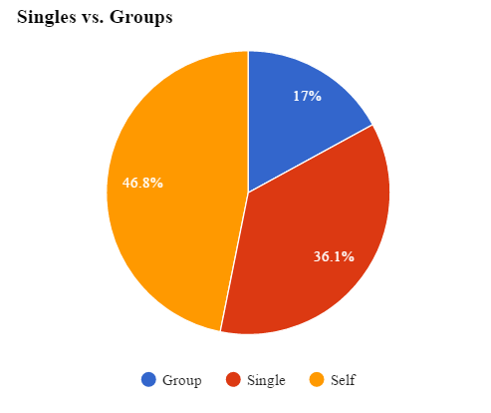

Figure 5 – 82.9% of responses prefer killing a single person (car passenger or pedestrian) rather than groups of people

It is clear that killing the least number of lives possible was of utmost importance to the participants, with 82.9% of responses indicating that it would be better if one person is killed (either car passenger or any other pedestrian) rather than a group of people.

This result compares well with findings presented by other papers. A study shows that the most preferred action was to maximize the number of lives saved, where a vast majority of participants actively or passively (take no action) choose to sacrifice themselves rather than killing a greater number of pedestrians [Navarrete et al., 2012]. Similarly, numerous studies highlight the fact that participants choose not to kill groups of people, even at the expense of their own lives [Bonnefon et al., 2015, Skulmowski et al., 2012, Li et al., 2016].

## Upholding the law

In a number of scenarios, participants also had to take into consideration basic road laws and whether characters were breaking or abiding by these laws. Considering only the responses received from these scenarios, which amounted to 1221 (22.9%) responses, not much importance was given to whether the pedestrians were obeying the laws or not. This may be the result of lack of observation from the participants. However, there was still a slight difference, with 5.2% more people choosing to save characters who were abiding the law (waiting on a red light, crossing on a green light, etc.). A similar result can be retrieved when considering solely Maltese participants – in 53.44% of the responses, law abiding characters were saved.

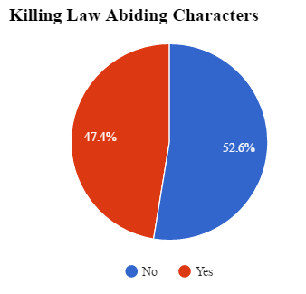

Figure 6 – In 52.6% of the cases, law abiding characters were saved, while 47.4% were killed

Following these results, it is clear that some participants believe that persons who abide the law should be prioritised and protected.

## Killing Self vs. Killing Others

From 4083 responses, 43.57% of participants decided to kill the driver in the self-driving car, which represents the participants themselves. One of the factors that could have played into this decision was the fact that the accidents were partly the driver’s fault, since their own car’s brakes were failing in these scenarios. Maltese participants opted to kill themselves in 42.31% of the case. Noteworthy is the comparison between genders – the majority of male participants, with 52.37%, chose to kill themselves, against the 47.34% of female participants and the 43.14% of participants who identify themselves as other genders.

When evaluating which characters participants decided to sacrifice themselves for (Figure 7), it emerges that participants would save all human characters rather than save themselves. However, when presented with dogs, only 36.9% of participants decided to kill themselves. Furthermore, 55.9% of participants decided that it is better to hit a car (killing its passenger), rather than kill themselves. When presented with a group of characters, an overwhelming majority of 74.22% decided to save the group.

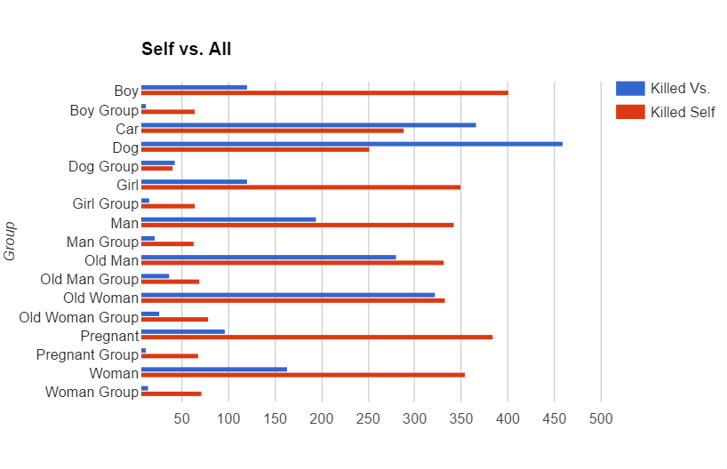

Figure 7 – Comparison of the choice to kill oneself against each of the other characters

## Ages

When comparing the ages of the characters – children, adults, and elderly people – a lot of information can be retrieved. Participants tended to prefer saving young children (Figures 8 and 9), where 17.6% were killed when presented against adults, and only 9.8% were killed against elderly people. Additionally, the trend of saving the young continues at higher ages – only 15.8% of participants chose to kill an adult when presented against elderly people (Figure 10).

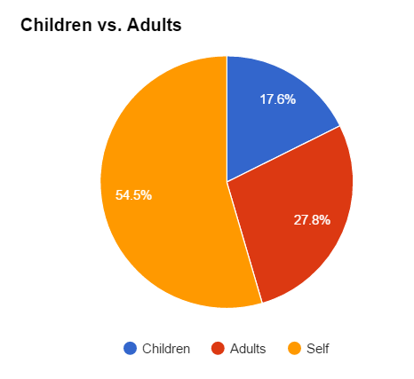

Figure 8 – Comparing children and adult kill rates

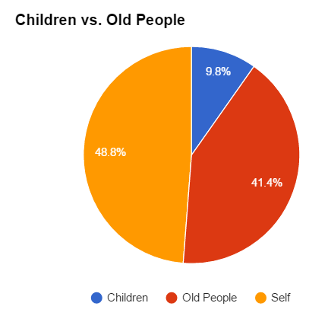

Figure 9 – Comparing children and elderly people kill rates

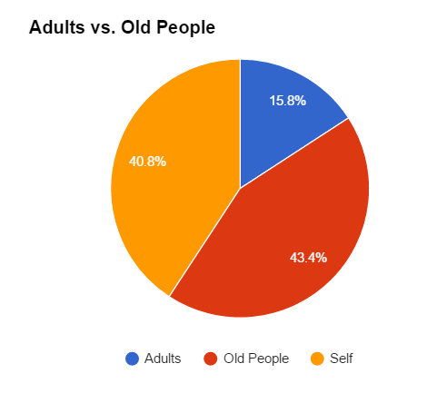

Figure 10 – Comparing adult and elderly people kill rates

It is clear that participants prefer to kill older people, while prioritizing the protection of young children. Presumably, these participants would want autonomous vehicles to somehow determine the age of the people in a scene and save the youngest people when such a scenario occurs.

## Time taken to make Decision

The average time taken to make a decision was approximately 1.36s, where participants were given 3s. This figure also includes the 401 responses in which no action was taken (which amount to 9.8% of the responses), for which time taken was recorded to be 3s. Considering only responses in which action was taken, the average time taken drops to approximately 1.18s. 15.7% of the responses arrived in the last available second (Fig. 9). An overwhelming majority (74.5%) of participants assessed the scenario presented and took action in less than 2 seconds.

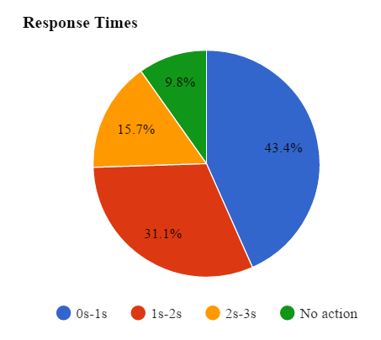

Figure 9 – Response Times

The results show that participants were given enough time to make their decision; with the majority taking less than one second to make their choice. However, this may also result in some inaccurate results due to a lack of observation.

Interestingly, the average time take for a decision increases to around 1.41s when a group of people is presented in the scenario. This implies that the addition of a group of people does not overwhelm the participants, even though the average decision time is slightly higher. This contrasts with a study in which it was concluded that when presented with a group of characters, response was faster and thus suggests that Utilitarian decisions can be made in a shorter amount of time [Skulmowski et al., 2012].

These results help in determining whether autonomous vehicles should ask the driver to take a decision when the scenarios presented by simulation occur in real-life.

## Evaluation Summary

Through the results presented, the most important decisions according to the participants can be listed as follows (highest priority at top):

1. If animals are present, kill them – participants prefer to kill a dog rather than any other character in the simulation;
2. Hit another car if possible (possibly killing the car’s passenger) – nearly 45% of participants decided to hit a car rather than killing themselves or other pedestrians;
3. Save groups of people – 82.9% of responses prefer killing a single person (car passenger or pedestrian) rather than groups of people;
4. Sacrifice oneself rather than killing other people – participants prefer to kill themselves rather than killing any other character (except dogs and other cars);
5. Save younger people – participants prefer to kill elderly people rather than adults or children;
6. Save law abiding people – around 53% of participants saved law-abiding characters;